Windows Software Center – Software Installation Guide
In an effort to make it easier to install some of the items that we know you need, we will use the Software Center feature. Some programs and add ins, allow for installation without admin rights when placed in the Software Center.
We have added the OneNote ClassNotebook Add in (For Teachers), the Learning Tools ClassNotebook Add in (All teachers and students), and Office Mix PowerPoint plug in that allows for video creation (All teachers and students). Other installs may be made available in this manner when possible.
Steps to Install software | Screenshots
- Click on the Start button in the bottom left corner | 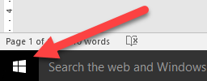
- Click All Programs Then scroll down until you see the folder for Microsoft System Center, click the little arrow next to the Microsoft system center and you will see the option for Software Center, click on that | 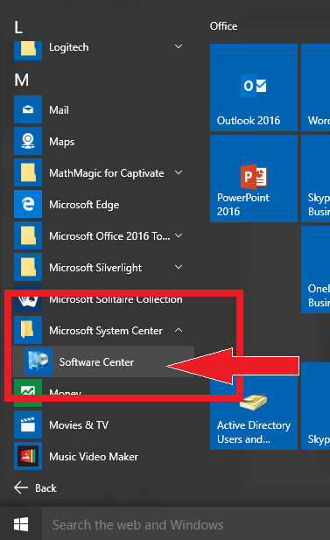
- When Software Center Opens, look for the link labeled “Find additional applications from the Application Catalog” and click on that. | 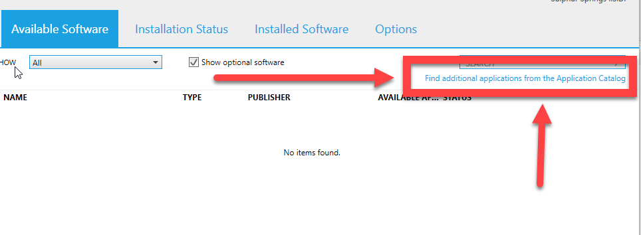
- Clicking on the link will open a website (please note this site needs to be opened in INTERNET EXPLORER. If your default browser is set to Edge, you will be redirected to Internet Explorer automatically. | SPECIAL NOTE FOR CHROME USERS: you will get a message saying to use Internet Explorer. You can copy they URL (web address) and open IE and then paste the web address there and it will work.
- Once on the Page, you will see the software that is available for installation, Select the program you want to install, and hit the Install button in the bottom Right. | 