New Teacher: Setup My Planner

The first time you login, the Setup My Planner wizard will appear and guide you through setting up your schedule of courses.
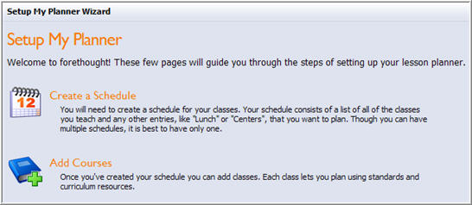
Next

2. Name the schedule. Include your name, grade level and subject (secondary).

3. Click Next at the bottom right to continue.

1. Click Next at the bottom right to begin the wizard.

Note: It is recommended to only have one schedule and add multiple entries (subjects that you teach).

Add Entries to the Schedule: Entries are courses that you teach

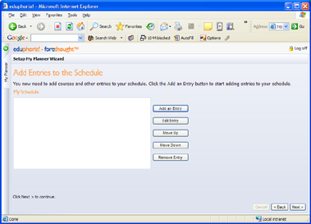
4. Click Add an Entry to locate the course that you teach.

5. Click Next at the bottom right.

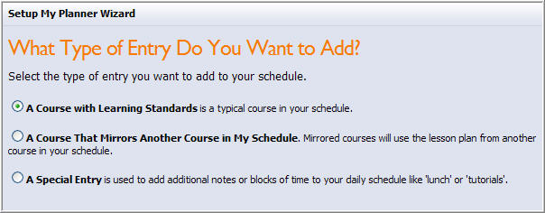
6. Select a Course with Learning Standards

7. Click Next at the bottom right.

Next
8. Locate the course that you teach by navigating through the Elementary or Secondary folder. Select your grade, and subject.

9. Click Next at the bottom right to continue.

10. Click Next again.

11. Select the course with the correct course code and click Next.

12. To add additional courses, repeat the process on the previous page to Add Entry and navigate to the course.
13. Continue clicking Next at the bottom right.
14. Note: You MUST complete the wizard by clicking "Begin Using Forethought."

