Tables and Printing

- Insert a table
- 6 columns
- 3 rows
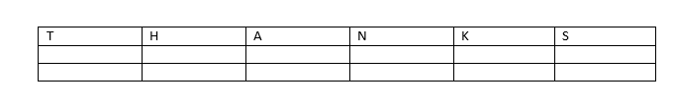
- Label the top boxes of the first row with T-H-A-N-K-S

- Have students type what they are thankful for.
- Adjust the width of the columns to fit the text entered
- Change the font style and size
- BOLD the letters in T-H-A-N-K-S
- Change the background color of the page
- Add a border to the page
- Walk students through where they would go to print

