Week 6 Directions

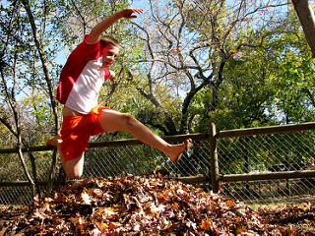After Thanksgiving dinner, you and your cousin decide to explore the neighborhood. At the end of the street, you notice a giant pile of leaves.
Together, you make a running start and leap right into the middle of the pile! Suddenly, the ground opens up beneath you, and you find yourselves sliding down a steep slide.
Write a story about what happens when you land at the bottom of the slide. Where are you? Include three different things that happen on your adventure, and conclude your story by telling how you and your cousin get back home.

Once you have typed your story make sure to add the following
- Background
- Images
- Borders
- Cool font
- Font color
- Format your paragraphs
- Add a title
- Center your title
- Add a table to the bottom of your story that looks like the following:
Name | Title

