Working in a Team Planner and Copying to Individual Planner

If you work with a team that will be creating lesson in the Team Planner, you no longer need the default template to appear in My Planner. This is because the content of the Team Planner will be copied into My Planner at the end of the week.

Delete Default Template in My Planner
- Launch forethought and select My Planner
- Glance at the calendar on the left. Select a future date that is not bolded (because you have not clicked on that date) by clicking on it. The changes that you make will be from that date forward.
- You will need to delete the default template for each course in your schedule one at a time.

1. To select the headings, in the default template, click on the white space AFTER the last heading.
2. Click and drag the mouse up to highlight all of the headings and then click on the Cut icon to remove the headings.
5. Follow the procedures on this page for EACH course in My Planner.

4. When you have completed the procedures on the left, click the “wrench” and Select Set as Default Text for Entry. Click Save (diskette).

Enter lesson plans into the Team Planner
- Select the entry and use the "Check out and edit" icon to check it out.
- The lesson becomes editable to add learning standards, attachments, etc.
You must “Check out and edit” to enter lesson plans or select the TEKS.

- When you save, the entry is "checked backed in." To continue to edit the
entry, you need to check out the entry again.
Note: Two team members cannot edit the same entry for the same day at the
same time. If you try to edit the entry that someone else has checked out, Forethought
will not let you check it out.

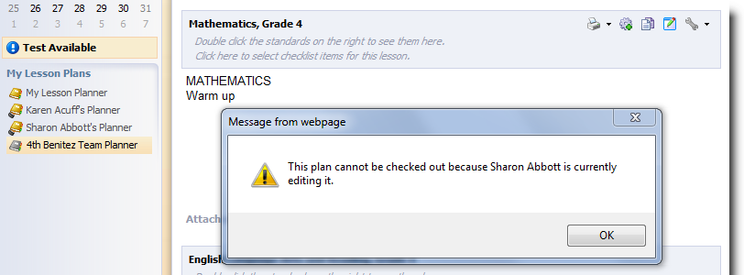

Copy Week: This option will only appear in the team planner in Week View. If selected, the entire week's plans will copy from the team to your own planner. It will copy like courses to like
courses.

Click the tiny calendar. Select View Week’s Plans
to go to week view.

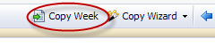

All teachers on a team should COPY from the Team Planner to My Planner:
1) The Standard Coverage Report won't give you credit for your standards if it's only in the team planner.
2) You can differentiate your lessons for your students if you copy from team planner to your individual planner.
3) The Team Planner could accidentally get deleted if all of the members are removed from the planner.
[Top]

